|  |
| --- |
| NSCC 2019 Workterm |
| **R2D2 Dome Manual** |
| R2D2 New Dome Project |

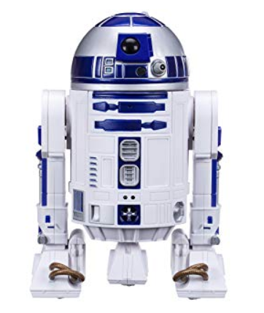

Project Owner : Todd Verge

Project Manager : Hyejung Bae (Cathy Bae)

Project Member : Rex Ramos

**CONTENTS**

1. How to use 3

1) Remote Control 3

2. 3D Printing 4

1) Overview 4

2) Result 4

3. Features 5

3) Display 5

2) Movement 11

4. Connection 15

1) Connection between Raspberry Pi (Dome) <-> Arduino (Dome) 15

2) Connection between Raspberry Pi (Dome) <-> Raspberry Pi (Body) 15

5. Test 15

1) 3.5’’ RPi TFT LCD Touch screen 15

2) LED Blinking using server 16

3) Camera 16

6. Future Features 17

7. Reference sites 17

1) R2D2 & 3D printing reference site 17

2) R2D2 3d printing file 18

1. How to use

1. Remote Control

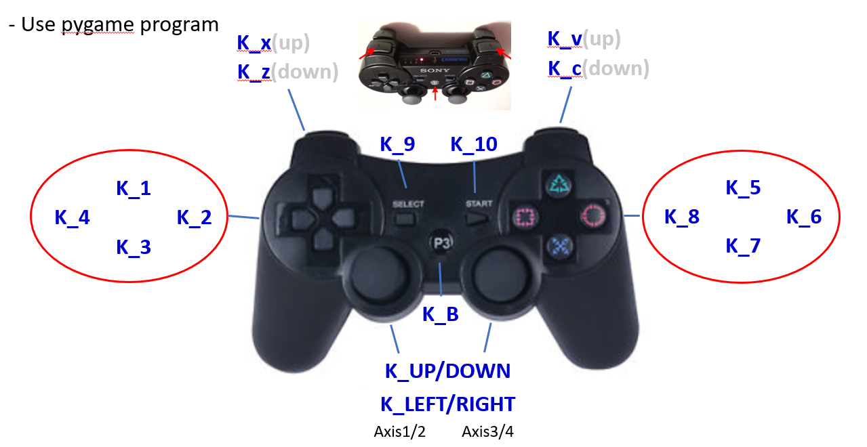

* Axis1/2 : Movement for Body(legs)
* Axis3/4 : Movement for DomeS
* K_9(Select key) : Making a Star Wars Theme Song
* K_10(Start key) : Making a Star Wars Theme Song
* K_c : Making panels movement
* K_1 / K_3 : Making panels movement or making a sound (randomly)
* K_7 : going faster
* Others : Making random sound

2. 3D Printing

1. Overview

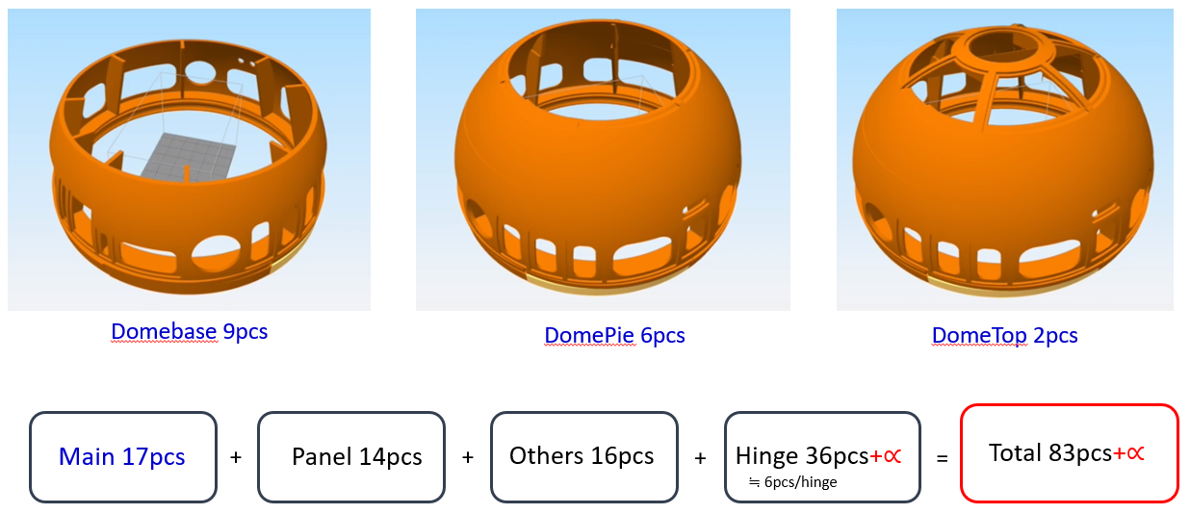



-3D files : <https://www.thingiverse.com/thing:1395937/files>

1. Result

- We printed **84pcs**, total time was approximately **245hours**.

- We made a priority to print, so we started printing big files before going home to

save time. We came to school early because we wanted to print first before scrum

meeting, and I came to school weekends to print for first 3 weeks because when

I thought about the whole process like printing, assembly, painting, I felt I don’t

have enough time to finish within 5 weeks.

3. Features

1. Display

1:Front Logic Display

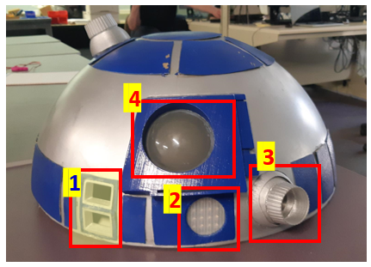

* 2 8x8 LED Matrix (MAX7219) : Green
* Random display code except 2lines of top/bottom each(for efficiency)
* I cut LED each because I want to use same code with Real Logic Display.
* Because 2lines are dead, If I did not cut(use 2 serial), dead lines are vertical.

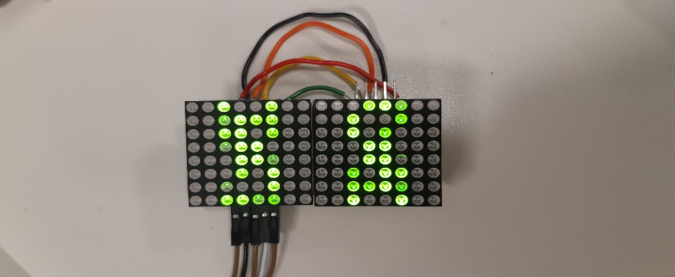

* Arduino code

#include "LedControl.h"

/*

Now we need a LedControl to work with.

***** These pin numbers will probably not work with your hardware *****

pin 12 is connected to the DataIn (19)

pin 11 is connected to the CLK (23)

pin 10 is connected to LOAD (24)

We have only a single MAX72XX.

*/

LedControl lc=LedControl(12,11,10,1);

/* we always wait a bit between updates of the display */

void setup() {

/*

The MAX72XX is in power-saving mode on startup,

we have to do a wakeup call

*/

lc.shutdown(0,false);

/* Set the brightness to a medium values */

lc.setIntensity(0,8);

/* and clear the display */

lc.clearDisplay(0);

}

void loop(){

setrandom();

}

void setrandom()

{

// setLed(int addr, int row, int col, boolean state);

lc.setLed(0, random(8) , random(8) , true); // set a random led

lc.setLed(0, random(8) , random(8) , false); // clear a random led

}

2. Processor State Indicators(PSI)

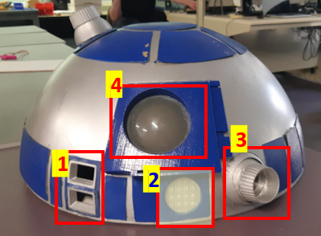

- 8x8 LED Matrix (MAX7219) : Red

- It was 4ea LED Matrix, and I cut it as 3 + 1(3 for rear display), but I cut it wrong

Way and it did not work. So I detach LED from PCB board, and made circuit

board for it. I want turning on the light when powered on, so I do not need chip

operated.

- I searched internet, and found

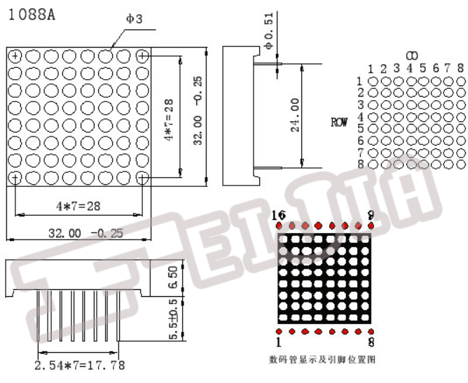

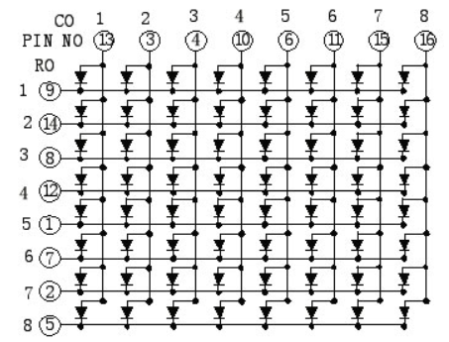 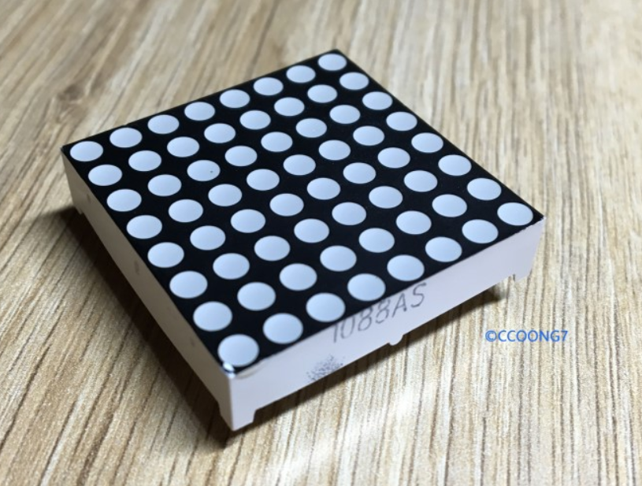

**1 8**

Side written Model name is bottom

-There are only 5v and ground line.

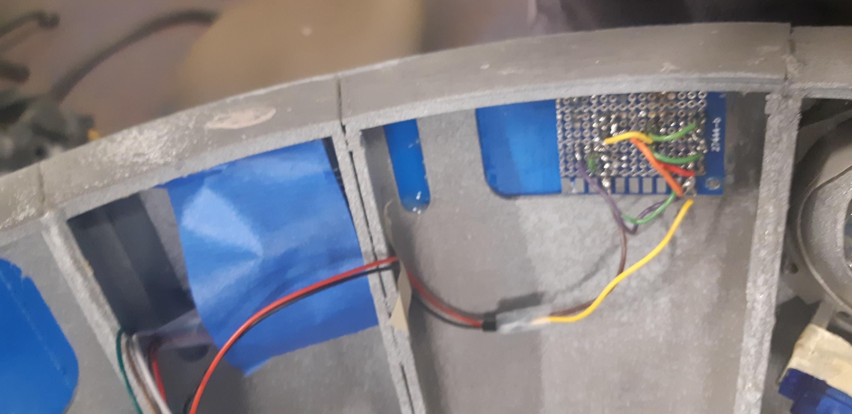

3: Holoprojector (side)

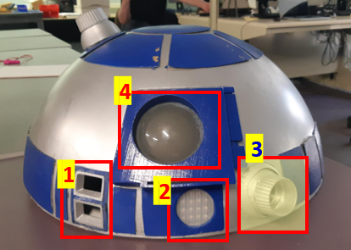

- Used 1 LED

- I was supposed to use several LEDs, but I need to make it move, so I changed

my plan. (3D file for this part looks like for 1 LED, I did take a picture for that)

4: Radar Eye

-Plastic dome

-I would like to use camera here, but one concern is sight. Plastic is not that

clear so it might not have good view. Second is hole. Dome body dose not

have a hole, so if you want to put camera or LED, you need to make a hole

first.

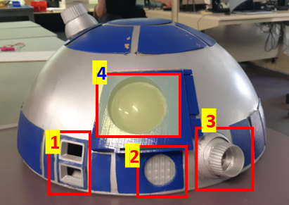

5: Rear Logic Display

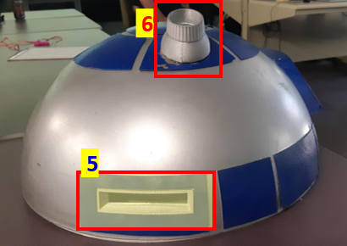

-3ea 8x8 LED Matrix(MAX7219) : Red

-Same code as Front Logic Display

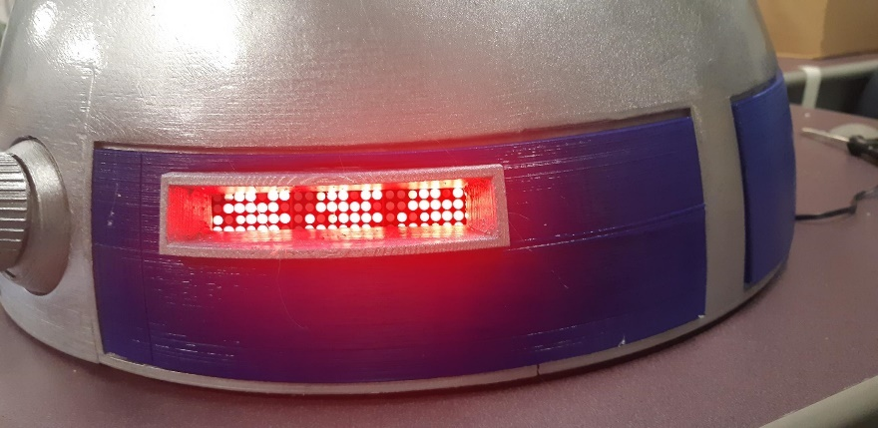

6:Holoprojector(Upper)

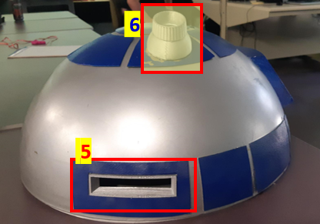

-no feature(for future)

-We had some ideas like use very bright light or laser, but we decided to leave

it for the future

1. Movement

-We would like to move as many as we can, (in motor shield, we can use in up to 12) we had 8 servo motors, but we didn’t have enough time, so we decided to make 4 moving panels and 1 holoprojector.

* Panels

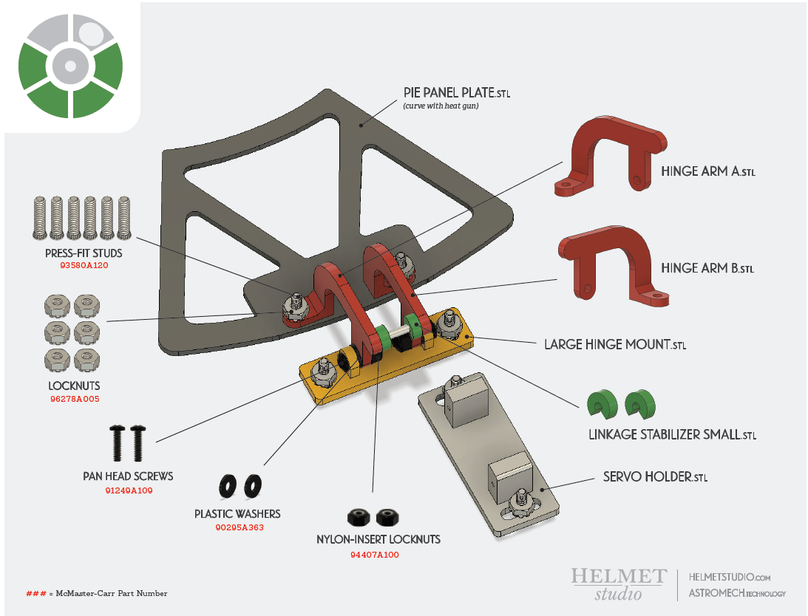

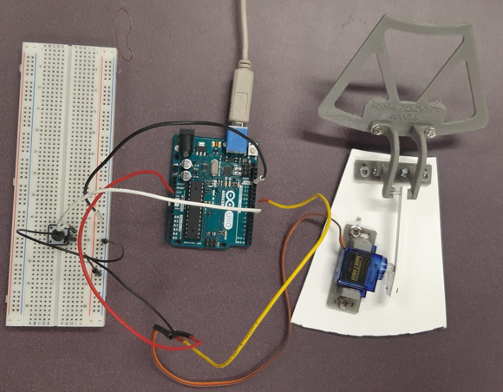

- I used this one, but size is not fit to our Dome so I needed to cut. So if you

want to do this again, please use another one.

- Arduino code

#include<Servo.h>

Servo servo[11]; //servo[11]

void setup() {

// initialize pins //i < 12, starts from pin2 ~ pin12

for(int i = 0; i< 12; i++){

servo[i].attach(i+2);

}

Serial.begin(9600);

}

void loop() {

// put your main code here, to run repeatedly: //i < 12

if(Serial.read()>0){

for(int i = 0; i < 12; i++){

servo[i].write(180); // 180deg

delay(500);

servo[i].write(0); // after 0.5sec it goes back to orig position

}

}//i < 14

else {

for(int i = 0; i < 14; i++){

servo[i].write(0);

}

}

}

* Holoprojector(side)

- Movement using servo motor

: Original plan was using 2 motors but we didn’t have a spring and if I use 2

servo motors they interrupted each other, so I use only 1 motor

Holoprojector was being controlled by DomeRPi attached in its GPIO pins

Code filename: HP_servo.py

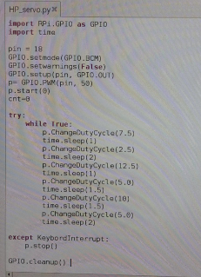

4. Connection

- Concept : Remote controller 🡪 Body Pi 🡪 Dome Pi 🡪 Arduino

* We would like to use own Raspberry Pi for Dome and connect with body Raspberry Pi wireless because Dome needs to rotate
* We can connect Arduino for Dome with body Raspberry Pi without using another Raspberry Pi(If we use wifi module for Arduino), but the reason why we tried to use another Raspberry Pi is we wanted to use 3.5’’ TFT LCD (this is for Raspberry Pi).

But, we could not apply it after all (time rush)

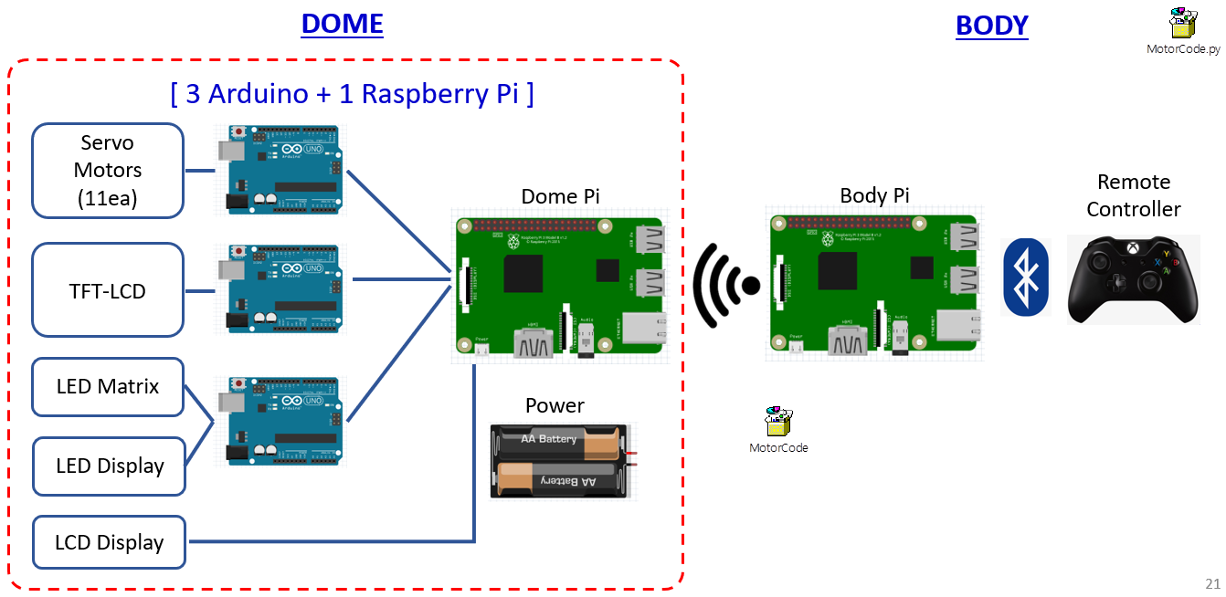

1. Connection between Raspberry Pi (Dome) <-> Arduino (Dome)

- We made a connection using serial port

1. Connection between Raspberry Pi (Dome) <-> Raspberry Pi (Body)

- We made a connection using wifi and then changed it using ADHOC

- We need wifi to install program and update, so we tried to use wifi first,

Body Raspberry Pi is version 2 so it didn’t have wifi module inside, we need

to use wifi usb for that.

- The reason why we use ADHOC is we want to make sure it will work in

everywhere without wifi

Codes for Body Rpi

1st version (Original)



2nd Version (Communicating with DomePi)



Ad-hoc network connection between two Rpi.

Body Rpi IP Address: 10.168.0.101

Dome Rpi IP Address: 10.168.0.102

1. Edit both Rpi /etc/network/interfaces

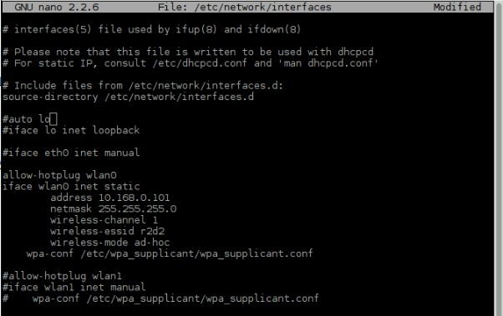

Change respective IPO address based on RPi

1. Disable dhcpcd service in terminal by doing “sudo systemctl disable dhcpcd”
2. Reboot the system

Setting up auto start of script at system bootup.

Dome Rpi:

1. From terminal do “sudo nano /home/pi/.config/lxsession/LXDE-pi/autostart”
2. At the bottom of this file, put in the full path of the script

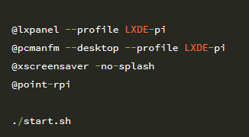

Full path of script

1. Reboot the system

5. Test

1. 3.5’’ RPi TFT LCD Touch screen

- If you follow the instructor, you can use it as a touch screen

- I made a video and displayed it, use this file as a screen saver. But we did not use

this because of lack of time

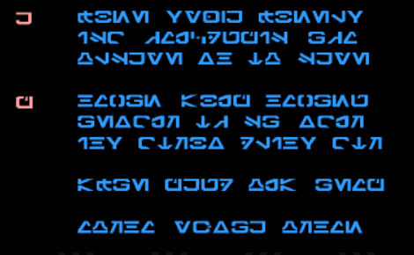

2) LED Blinking using server

-If I click “Turn On Red” on server, LED is blinking 😊

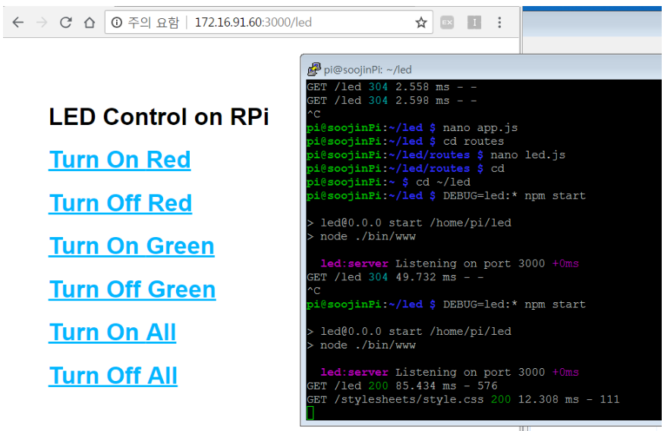

1. Camera

* There was a Raspberry Pi camera, so I took a picture, saved a video, made a streaming service.

I could not have captured, so this picture is from site where I referred

(<https://cosmosjs.blog.me/221339215946>, this is Korean site, sorry)

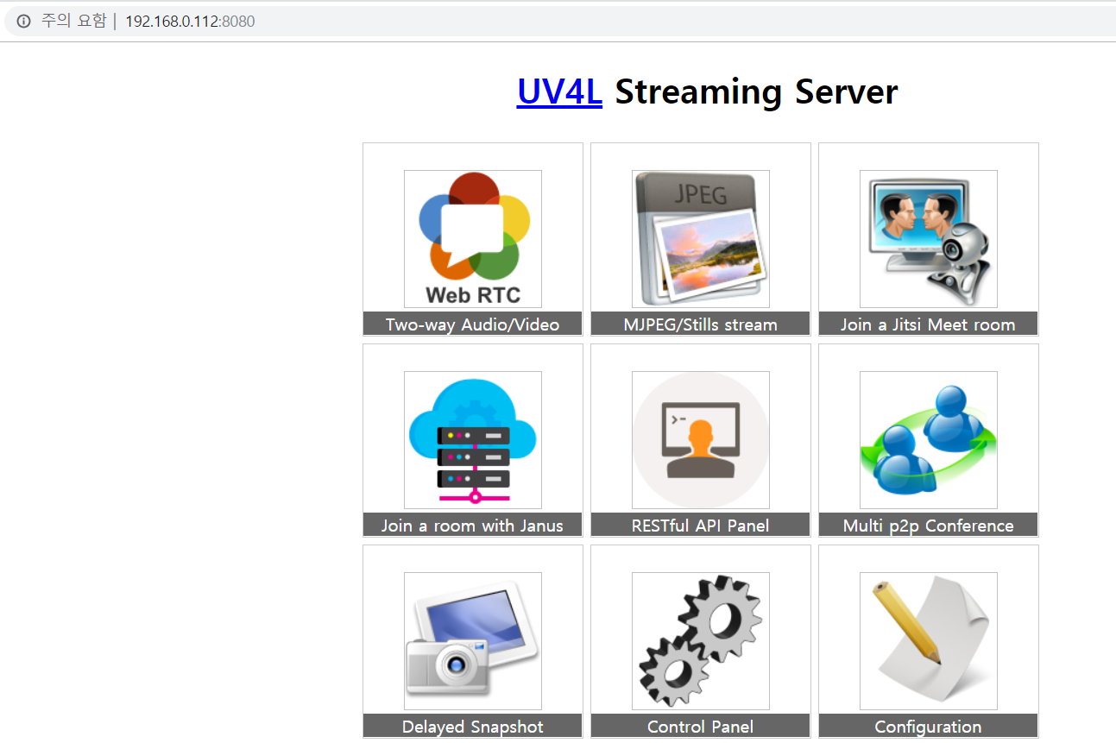

6. Future Features

- Movement for more panels

- Periscope

- Camera

- Adding AI

: I would like to apply a little of AI. But I couldn’t. If I have a USB mic

(and time) I wanted to install google analytic, so we can use Alexa.

If I say “R2, Turn on the music”, he will play music.

Please try this.. Make him more robotic.

7. Reference sites

1) R2D2 & 3D printing reference site

.1 R2D2 Builders club :<http://astromech.net/>

.2 Mike Baddeley’s site: <https://www.thingiverse.com/mrbaddeley/about>

.3 3D Printed Droids : <https://www.3dprinteddroids.net/>

.4 STL file viewer : <https://www.viewstl.com/>

.5 3D printer calibration - https://www.youtube.com/watch?v=JihFYdVnEj0

2) R2D2 3d printing file

.1 Dome parts - <https://www.thingiverse.com/thing:1395937/files>

.2 Hinges - <https://astromech.technology/construction/s-dome-hinges/>

🡪 As I mentioned, Size is not fitted in Mike Baddeley’s Dome after all,

so I had to cut a little. Just use hinge files in Dome parts or use another one.